

EE4228 (Intelligent Systems Design)

Assignment 2

Online Face Detection and Recognition System Based on Deep Neural Network

School of Electrical and Electronic Engineering
Academic Year 2025/26
Semester 2

Table of Contents

- Purpose / Project Objectives

- Project Summary

- Methodology

- Results

- References

- Project Objectives
The purpose of this project is to design and implement a deep learning-based human face detection and recognition system that can accurately detect and recognize faces in real-time using a live camera. Using a laptop webcam to recognize a small, fixed set of group members, drawing a bounding box around each detected face and overlaying the person’s name and confidence score.
- Project Summary
The project takes a two-step approach and compares the two main pipelines:
- Facial detection via MTCNN compared to YOLOv8
- Facial recognition via FaceNet compared to ArcFace
The final design uses YOLOv8 for face detection with FaceNet for face recognition, which offers a balanced trade‑off between accuracy and speed for the specific use case of recognizing a limited number of known faces on a consumer laptop.

- Methodology
3.1 Facial Detection
Facial detection is the task of locating human faces within an image or video frame. The system purely detects and localises facial regions through the drawing of bounding boxes around detected faces.
3.1.1 Multi‑task Cascaded Convolutional Neural Networks
Multi‑task Cascaded Convolutional Neural Networks (MTCNN) is a deep learning–based framework for face detection and alignment (Zhang et al., 2016). The method integrates classification and regression objectives into a unified cascaded architecture to improve detection accuracy while maintaining computational efficiency. MTCNN uses convolutional neural networks (CNNs) trained end-to-end and comprises a three‑stage cascade of CNNs, the Proposal Network (P‑Net), the Refinement Network (R‑Net), and Output Network (O‑Net).
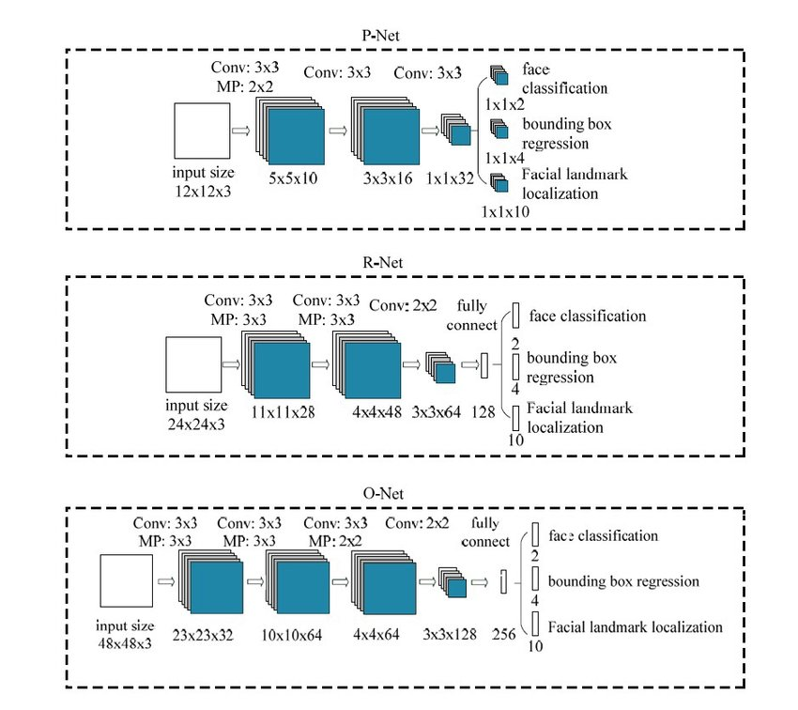
Image 1: Diagram of MTCNN architecture.
MTCNN is based on multi-task learning and cascaded architecture as shown in Image 1. The three progressively stricter CNN stages perform fundamentally similar operations, Bounding Box Regressions which provides initial estimates for the bounding boxes and Face/Non-Face Classification which gives a score indicating whether a region contains a face or not.
The first stage of MTCNN uses the P-Net to scan the image at multiple scales. Input images are scaled down progressively to create an image pyramid allowing the P-Net to detect faces of various sizes across an image. At each scale, the P-Net slides over the image and generates bounding box proposals for regions that might contain faces. The bounding boxes are then processed and filtered with Non-Maximum Suppression (NMS) to remove overlapping boxes.
The second stage of MTCNN uses the R-Net to further refine these bounding boxes, rejecting false positives and improving the precision of the face regions. Similar to P-Net, the R-net does Bounding Box Regressions and Face/Non-Face Classification before applying another round of NMS to filter out overlapping or low-confidence detections. However, it applies stricter classification thresholds and more precise bounding box adjustments.
The final stage, the O-Net refines the bounding boxes even further and additionally detects five facial landmarks. The O-Net predicts the coordinates of the left eye, right eye, nose, left mouth corner, right mouth corner before conducting a final NMS, ensuring that the best bounding boxes and landmarks are kept while filtering redundant detections.
Therefore, MTCNN not only detects faces, but it also predicts key facial landmarks to aid in the alignment of the face before further processing.
3.1.2 You Only Look Once
You Only Look Once (YOLO) is a single-stage deep learning framework for real-time object detection (Redmon et al., 2016). YOLO reframes object detection as a single regression problem that directly predicts bounding boxes and class probabilities from full images in one forward pass of a convolutional neural network. YOLO performs localization and classification simultaneously within a unified network for architectural simplicity. The YOLOv8 architecture used in the project is illustrated in Image 2.

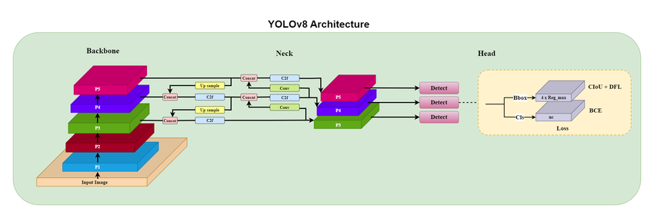
Image 1: Diagram of YOLOv8 architecture (Biswas et al., 2023)
The input image is first resized into a fixed 448 x 448 image, then divided into a grid, with each grid cell being responsible for predicting objects that could fall within the grid cell. In addition to predicting the objects, i.e. the bounding boxes, within the grid cell. Each bounding box also has a class confidence attached to it.
Only after the bounding boxes and class confidences are predicted is post-processing applied with Non-Max Suppression (NMS), which reduces the bounding boxes that have high overlap into a singular bounding box of the highest-class probability.
3.2 Facial Recognition
Facial Recognition determines the identity of a person through the analysis of facial features. The system would extract distinctive features such as the distance between facial landmarks, the shapes of facial components and high-level feature embeddings. Through a comparison with stored representations of known identities in a database, the system determines who the person is.
3.2.1 FaceNet
FaceNet is an embedding‑based face recognition model and implements a deep metric learning framework (Schroff et al., 2015). FaceNet learns through mapping from face images to a compact Euclidean embedding space whereby facial similarity is represented by distances between feature vectors based on the function 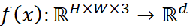. The parameters are optimised using a triplet loss objective.
The deep CNN in FaceNet functions as a feature extractor, processing aligned image into a 128-dimensional embedding vector which is L2-normalized. This constrains embeddings to lie on a unit hemisphere. Similarity comparisons are then made using squared Euclidean distance or equivalent cosine similarity between embeddings.

FaceNet is then trained using triplets of images. Given the Anchor (A), a face image, the Positive (P), another image of the same person is mapped to nearby points. The Negative (N), an image of a different person is then mapped far apart. Online triplet mining is conducted to select the triplets and training minimises the sum of triplet losses over all triplets in the dataset.
Therefore, FaceNet performs representation learning rather than direct classification through a similarity function.
3.2.2 ArcFace
ArcFace is a method that improves embedding discriminability via Additive Angular Margin Loss instead of the traditional Softmax Loss. ArcFace calculates the distance between faces using the cosine distance. Both the features and Fully Connected (FC) weights are normalised and the inner product taken. Instead of using raw angular similarity (cos$θ$), ArcFace adds an angular margin of +m, cos($θ$+m). This allows the model to learn more compact clusters for the same person (intra-class compactness) and larger gaps between different people (inter-class discrepancy).
The formulas of the softmax and Additive Angular Margin loss are as follows:

- Comparison
4.1 Facial Detection
The matrix below is used in the comparison of MTCNN and YOLO (Dhoul et al., 2025).
Metric/ System |  | MTCNN | YOLO
Detection Accuracy | Precision | 0.89 | 0.95
 | Recall | 0.70 | 0.88
 | Mean Average Precision (mAP) | 0.75 | 0.94
Detection Speed
Localization Quality (Average IoU) |  | 0.70 | 0.80
Detection accuracy consists of 3 parameters, precision, recall and mean average precision. Precision indicates how many detected faces are correct detections. Recall indicates how many real faces were successfully detected. Mean Average Precision (mAP) summarizes detection accuracy across different confidence thresholds.
Detection speed refers to how quickly the model process images of video frames and is measured in frames per second (FPS) in this study. Using the specific hardware below, there was a negligible difference in the FPS observed between MTCNN and YOLOv8.

** INSERT SPECIFIC HARDWARE SPECS HERE**
It should be noted that research has shown that YOLOv8 has a larger model size than MTCNN, which could pose an issue in ultra-low-resource devices, which is more common in older consumer laptops.
Localization Quality measures how accurately the predicted bounding boxes overlap with ground-truth face locations. This study evaluated it using Intersection over Union (IoU).
As model size was not a constraint in this project, YOLOv8 was thus the most appropriate model.

4.2 Facial Recognition
The matrix below is used in the comparison of FaceNet and ArcFace.
Metric/ System | FaceNet | ArcFace
Verification Accuracy
False Acceptance Rate
False Rejection Rate
Identification Accuracy

Verification accuracy measures how correctly the model determines if two faces belong to the same person. This study evaluates the accuracy of benchmark datasets. FaceNet achieved a then-record accuracy of 99.63% on the Labeled Faces in the Wild (LFW) dataset and 95.12% on the YouTube Faces DB.
False Acceptance Rate (FAR) is the rate which the system incorrectly accepts two different people as the same person. False Rejection Rate (FRR) is the rate in which the system incorrectly rejects two images of the same person.
Rank-1 accuracy is used to measure identification accuracy measures how often the correct identity appears as the top prediction.

Bibliography

Biswas, Supratim & Acharjee, Suvojit & Ali, Asfak & Chaudhuri, Sheli. (2023). YOLOv8 based Traffic Signal Detection in Indian Road. 10.1109/IEMENTech60402.2023.10423520.

A. S. Dhoul, B. Saifee, R. Patel, S. Vishwakarma and R. Ahluwalia, "Performance Evaluation and Comparison of YOLOv8, MobileNet-SSD, and MTCNN for Face Detection in Smart Attendance System," 2025 13th International Conference on Intelligent Systems and Embedded Design (ISED), Raipur, India, 2025, pp. 47-53, doi: 10.1109/ISED67359.2025.11405179. keywords: {Performance evaluation;Visualization;Accuracy;Error analysis;Face recognition;Nearest neighbor methods;Real-time systems;Face detection;Tuning;Videos;Smart Attendance System;Face Recognition;Deep Learning;Hyperparameter Tuning;OpenCV},

